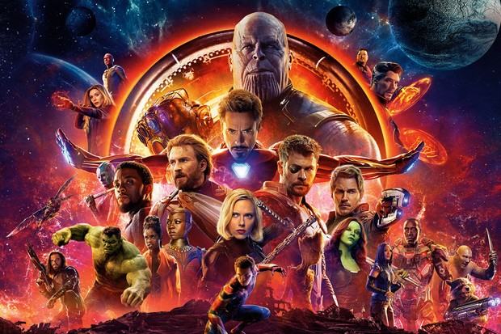
Structure of a Story
We will use our Brain Pockets (Imagination, Loathe, Memory, Fact) as inspiration for our stories

Traditional or Catchy Beginnings
- Once upon a time
- In a galaxy far away
- I thought it was going to be a normal ______________
- No one ever knew what it was like
- Rrrrooooaaaarrrrr! / Kkkkaaaabbbboooommmm (after this there was a chase between a bear and a boy.)
- I am ________. I am a _________. It is not as easy as it looks. (based on spiderman)

A must in every story (almost):

Good and bad characters (protagonist and antagonist)
Setting (a place…or many places, cool places)
Things that go wrong (stealing, extreme weather)
Detailed Sounds
A happy ending (we know there are other ways to end a story but let's use this formula for now)

And they Live Happily Ever After (the ending)
End your story with a lesson
Someone with special talent becomes a legend (a hero) and goes down in history

