Simple Paragraph

EXAMPLE of a paragraph:
If you are looking for a great family pet, there is no better choice than the unique Siberian Husky.

If you are looking for a great family pet, there is no better choice than the unique Siberian Husky. For starters, even though they can get really big they actually do not eat very much. Secondly, Siberian Huskies are beautiful dogs! The final reason Siberian Huskies are so great is because they are incredibly loyal, making them a great member of the family. To conclude, Siberian Huskies are arguably one of the best breeds of dogs you can have.
​
A PARAGRAPH is made up of a TOPIC sentence, SUPPORTING sentences, and a CONCLUDING sentence.

The TOPIC sentence is where we identify what we are going to be talking, along with an opinion or a "stance" about that topic.
Our SUPPORTING sentences are complete sentences that help prove or support the opinion or "stance" that we said in our first sentence.
The CONCLUDING sentence is the final sentence that wraps up and re-states our opinion about the topic, often in a creative way.
Think of a PARAGRAPH like a delicious hamburger:
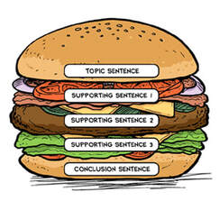

*Remember: A Topic sentence clearly identifies the topic, as well as the writer's "stance" or opinion about the topic. A topic sentence does not however, include any supporting details.

EXAMPLE:

Step One: Identify the main point in your piece of writing:
- Siberian Huskies are great dogs.

Step Two: Connect the What and Why to your main idea:
- What: Huskies are unique animals.
- Why: They make great family pets.

Step Three: Write an opening statement, or Topic Sentence.
- Siberian Huskies are unique dogs that make great family pets.

"Jazz it up!" Use your creativity to make it interesting.

