Science: Types of Energy
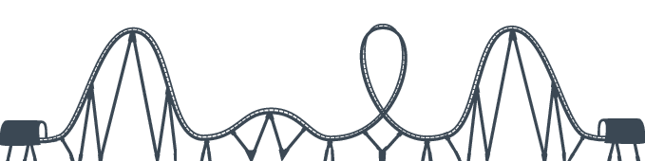
Roller Coaster Poster

Your job: You need to design (draw) a roller coaster to demonstrate your understanding of energy terms.

Your roller coaster needs to include the following:
- A name…on a sign at the beginning of your roller coaster (like…Monster Magnet)
- Neat colouring
- Label all the following forms of energy
- chemical energy (batteries / solar panels to power your roller coaster)
- electrical energy (anything you plug in…for example, lights for night riding)
- nuclear energy (a nuclear power plant that produces electricity for lights or sound)
- electromagnetic energy (for example, walkie talkies for security guards)
- sound energy (speakers playing your favourite music / a speakers welcoming people to your roller coaster, "Welcome to Monster Magnet…the world's greatest roller coaster")
- gravitational potential energy (stored energy related to the object's height)
- elastic potential energy (stored energy associated with objects being compressed or stretched…could this be how your roller coaster stops?…think of a fighter jet landing on an aircraft carrier)
- thermal energy (rocket boosters)
For example:
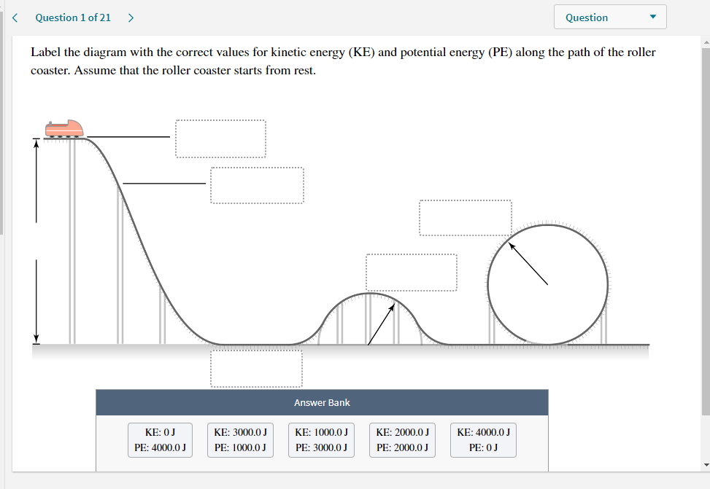
Although…your roller coaster will be WAY more artistic!

